

PROJECT REPORT

ON

**Resound**

**Under the Guidance of: Dr.Abhishek Thakur Submitted By:**

**Designation : Mentor Madhav Goyal (2011981262)**

**Department: Computer Science Akhilesh Thakur (2111981020)**

**and Engineering Akshita (2111981026)**

**Anjori (2111981033)**

# **CONTENTS**

**Title** **Page No.**

|  |  |
| --- | --- |
| 1. Declaration | 3 |
| 2. Acknowledgement | 4 |
| 3. List of Figures and Tables | 4 |
| 4. Introduction | 5 |
| 4. I Project Category | 5 |
| 5. Abstract | 5 |
| 6. Work Done | 6 |
| 6.1 Overview | 6 |
| 6.2 Purpose | 6 |
| 6.3 Overall Description | 6 |
| 6.3. I Product perspective | 6 |
| 6.3.2 Product Function | 6 |
| 6.3.3 Operating Environment | 7 |
| 6.3.4 Design and Implementation Constraints | 7 |
| 6.4 External Interface Requirements | 8 |
| 6.5 Other Non-Functional Requirements | 9 |
| 6.6 Diagrams | 10 |
| 7. Conclusion and Future Scope | 14 |
| 7.1 Conclusion | 14 |
| 7.2 Future Scope | 14 |
| 8. References | 14 |
| 9. Snapshots | 15 |

## **DECLARATION**

We hereby declare that the project work titled, "**Resound | An Interactive Music Sharing and Streaming Platform**" submitted as part of Bachelor' s degree in CSE, at Chitkara University, Himachal Pradesh, is an authentic record of our own work carried out under the supervision of Dr. Abhishek Thakur.

Signature(s):

**ACKNOWLEDGEMENT**

We would like to express our deepest appreciation to our project supervisor, Dr. Abhishek Thakur, for his guidance, support, and expertise throughout the development of our music player. We are grateful for his invaluable insights and feedback that helped us refine our ideas and make critical decisions.

We would also like to thank our team members, Madhav Goyal, Akhilesh Thakur, Akshita and Anjori, for their hard work and dedication in bringing this project to fruition. Each team member brought unique skills and perspectives to the project, and their collaboration was essential to the success of the music player.

We extend our gratitude to the outside consultants who generously shared their expertise with us. Their insights and feedback helped us refine the functionality and usability of our music player. We would like to express our gratitude towards our parents member of CSE Department for their kind co-operation and encouragement which helps us in the completion of the project.

Lastly, we thank all of the users who provided valuable feedback that helped us improve the music player. We are proud of what we have accomplished and we hope that our music player will bring joy and entertainment to music lovers everywhere.

List of Figures and Tables

|  |  |
| --- | --- |
| Figures | Page No |
| Figure l: E-R Diagram | 10 |
| Figure 2: Class Diagram | 11 |
| Figure 3: Sequence Diagram | 12 |
| Figure 4: Use Case Diagram | 13 |

**Project Title: RESOUND | An Interactive Music Sharing and Streaming Platform**

**Introduction**: Music is an integral part of our lives and has the power to evoke emotions, memories, and moods. In today's digital age, music players have become an essential tool for people to listen to their favourite music anytime, anywhere. The objective of this project is to design and develop a music player that offers the user with an easy-to-use interface.

In this report, we will discuss the development of our music player, including the design, functionality, and features. We will also highlight the challenges we faced and the solutions we implemented. Our goal is to provide a comprehensive overview of our project and demonstrate how our music player can meet the needs of today's music lovers.

**Project Category**: In my view this project belongs to software development . We need to design the user interface and user experience of the application, including features such as playlists, music library management, and playback controls.

**Abstract**: This project aims to design and develop a music player that offers a user-friendly interface. Our approach involves integrating cutting-edge audio technology with intuitive design principles to create a music player that meets the needs of music lovers. The project provides seamless integration with the music player, allowing users to control their music playback and access their music library on the go. Our project has the potential to improve the music listening experience for people around the world and set a new standard for music player design and functionality.

**Work Done**:

**Overview**: User interface design: This involves designing an intuitive and user-friendly interface for the music player that allows users to easily browse, search, and play their music.

Audio playback functionality: This involves implementing the core functionality of the music player, which is to play audio files.

Music library management: This involves managing the user's music library, including adding/removing music, organizing music by artist/album/genre.

Audio equalization: This involves adding equalization controls to the music player, which allows users to adjust the frequency response of the audio output to suit their preferences.

**Purpose**:

l. To allow users to play and listen to music.

1. Allow users to listen to music whenever and wherever they want.
2. To customize their listening experience to suit their preferences.

**Overall Description**:

1. Product Perspective:

This software system is user friendly. The product have various features, such as the ability to manage a music library and adjust audio settings.

1. Product Function:

The product function of a music player is to allow users to play and listen to music. The core function of a music player is to read audio files, decode them, and play them.

3. Operating Environment:

This project works on the following:

l. Operating System — Windows 10.

2. Text-Editor: VS Code.

3. Technologies used: HTML, CSS, JavaScript.

4. Design and Implementation constraints:

* Platform Compatibility
* Audio Format Support
* Resource Limitations
* Licensing and copyright
* Storage Capacity

**External Interface Requirements**:

1. User Interface:

* It will be easy to use and user friendly.
* It have standard playback controls.

2. Software Interface:

This whole project works on browsers like Chrome, Firefox etc. and is based on the technologies like HTML, CSS, JavaScript.

Other Non-Functional Requirements:

1. Performance Requirements

It gives quick responses. It is time saving.

1. Portability Requirements

User can use it from anywhere.

1. Availability Requirements

This system is up and running whenever needed.

1. Scalability Requirements

It meets the needs for which it was build.

1. Security Requirements

This system provides basic security authentication

1. Safety Requirements

It keeps the records. Also, it is safe from various attacks.

1. Usability Requirements

The user will be able to play music.

1. Reliability Requirements

It is available to the user all the time.

1. Supportability Requirements

It is supported by all the browsers like chrome, Firefox etc.

10. Efficiency Requirements

It works with good efficiency.

* ER-Diagram:

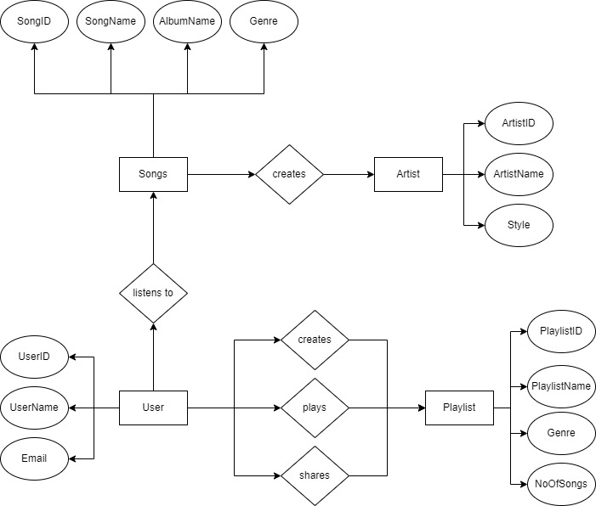

* Class Diagram:

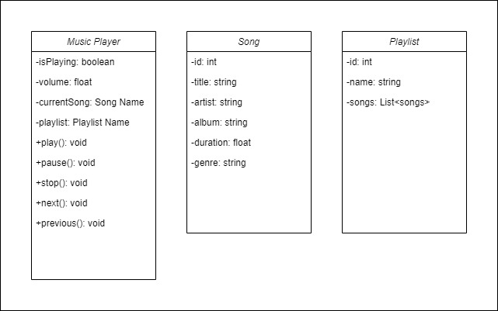

* Sequence Diagram

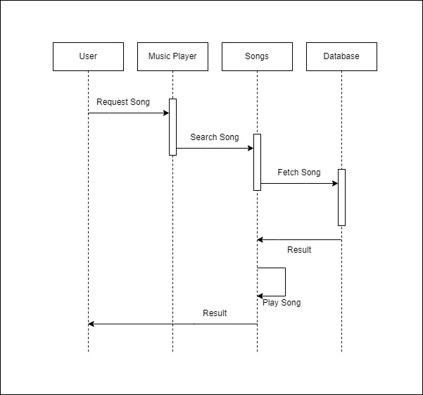

* Use Case Diagram

## Resound UseCase

## CONCLUSION AND FUTURE SCOPE

CONCLUSION: This application will be very beneficial to people especially music lover’s.

FUTURE SCOPE:

Integration of Social and Collaborative Features: Music is a highly social activity, and users often enjoy sharing their favourite songs and playlists with others. Therefore, future versions of the music player could integrate social and collaborative features such as the ability to create and share playlists with friends, follow other users and discover new music, or even collaborate with other users on a shared playlist.

Integration of Artificial Intelligence and Machine Learning: With the increasing sophistication of AI and machine learning technologies, music players could leverage these capabilities to provide more personalized and intelligent music recommendations, adapt to user preferences over time, and even generate new music based on user inputs.

Augmented Reality and Virtual Reality Integration: Augmented reality and virtual reality technologies could be integrated into music players to create immersive and interactive music experiences. For example, users could experience concerts or live performances from the comfort of their homes, or even create their own virtual music environments

REFERENCES:

### [l] https://www.w3schools.com/

### [2] <https://stackoverflow.com/>

SNAPSHOTS:

The home page will look like this.



**Header**

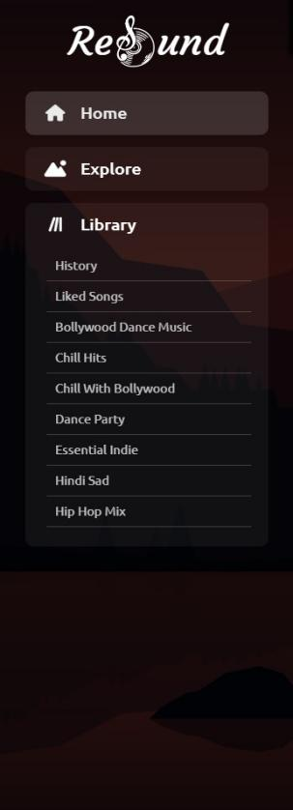



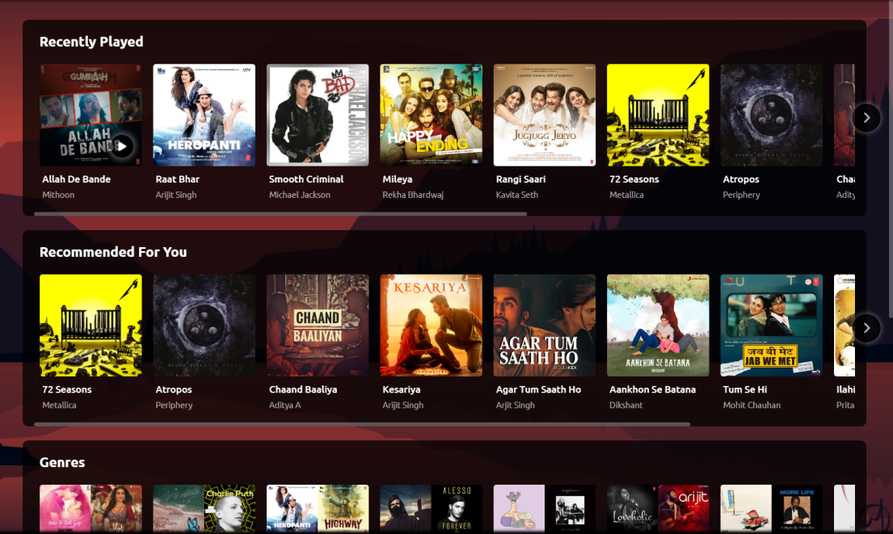

**Main Content Window**

**Navbar**

**Music Player**

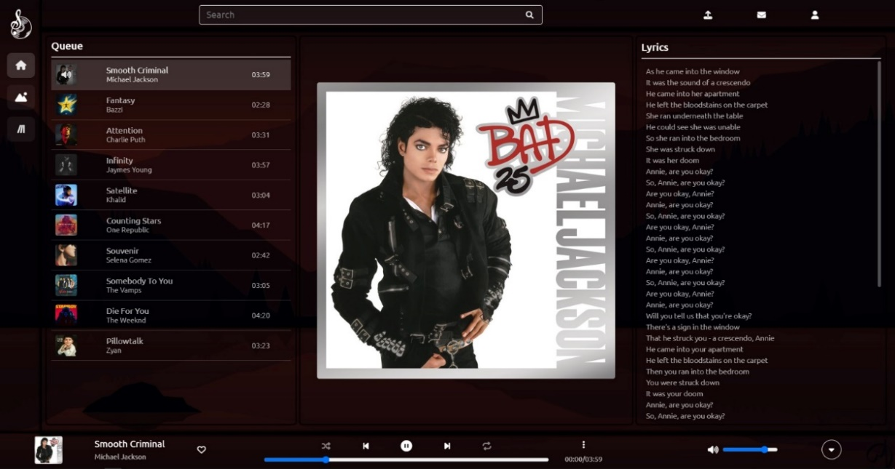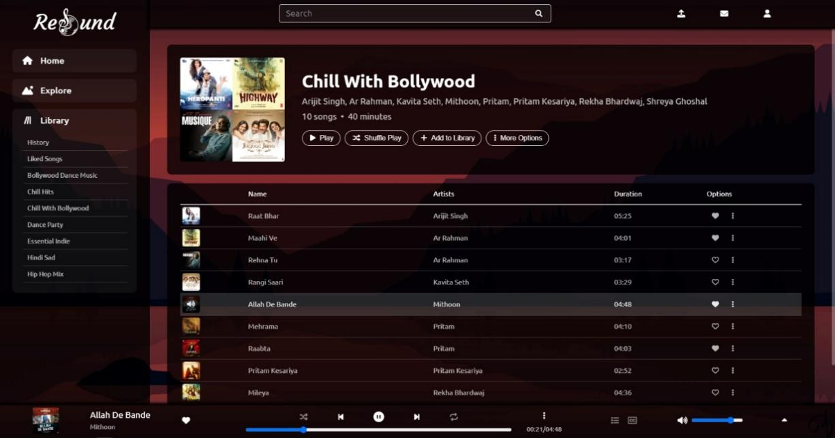

Playlist section

Extended Player

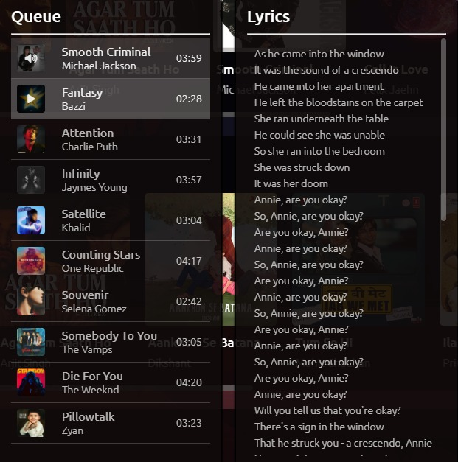

Queue and Lyrics Tab

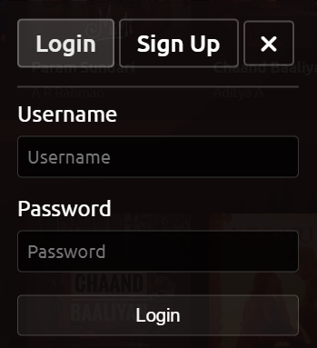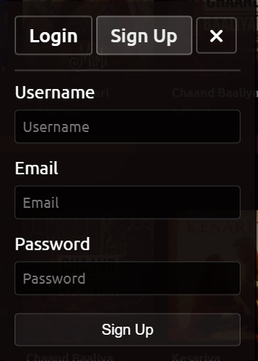

Login and Sign Up Tab